Name:_________________
STATION --- EYE
Use pg137-138 to label the diagram and fill in the table
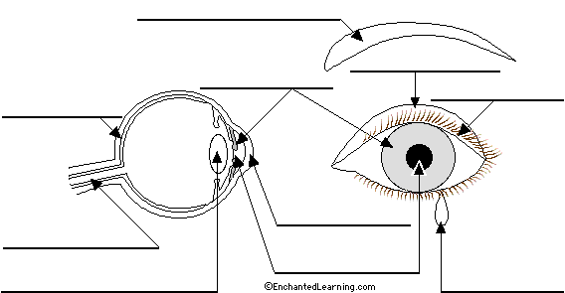
Find each part on the model
Below in table write the function of each part of the eye
Part | Function

STATION ---Reflection
Read pg125 and prac p132. Conduct the prac and draw what you see (fig 4.3.22)
Draw a diagram of reflection from plane mirror

What is the law of reflection?
__________________________________________________________________________________

STATION ---- Plane Mirror
Read pg 126, look at fig 4.3.9
Describe what a plane mirror is and what the image formed in a plane mirror looks like.

STATION ---- Refraction
Read pg 126 & 127
Look at fig 4.3.21 pg 131 Look at set up and draw what you see.
Explain the reason for this. __________________________________________________________________________________________________________________________________________________________________________________________________________________________________________________

STATION ---- Total Internal Reflection
Read pg 129
Look at fig 4.3.16 explain why there are 2 sharks

STATION -----BENDING LIGHT
Read pg 133. Do the activity using a glass block
Explain what happens in this task

 | Angle of incidence | Angle of refraction
Light entering glass from air
Light entering air from glass

STATION ---- Firework Glasses
What did you see?
Why do you see this?

STATION ---- CONVEX and CONCAVE
Read pg 134--136
Draw fig 4.4.2 then explain what happens with each type of mirror / lens

Use the light box to replicate the diagrams above

STATION -----Forming an image
Read the box on pg 134
What type of lens is found in a magnifying glass?____________________
Do the activity. Explain what you saw using the words image and focus

